**Bug Report**

**Defect** #**1:**

|  |  |
| --- | --- |
| ID number | #11 |
| Name | Zip/Postal code – Accepting Invalid Postal code |
| Reporter | Jabez Cherian Thomas |
| Submit Date | 05/09/2022 |
| Summary | When zip/Postal code field entered with invalid characters on registration page, zip/Postal code accepted as valid. |
| URL | https://www.betonline.ag/ |
| Screenshot | Attached |
| Platform | Windows |
| Operating System | Windows 10 |
| Browser | Chrome 53 |
| Severity | Minor |
| Assigned to | - |
| Priority | Low |

**Description**

When zip/Postal code field entered with invalid characters on registration page, zip/Postal code accepted as valid.

**Steps to reproduce**

* Go to ‘www.betonline.ag’
* Click on ‘Join’ button.
* add invalid characters on Zip/Postal code field (see screenshot)

**Expected result**

Proper field level warning should be displayed (i.e,Please enter valid zip/postal code )

**Actual result**

Not as Expected

Field level warning not displayed Zip/Postal code has been accepted

**Screenshot**

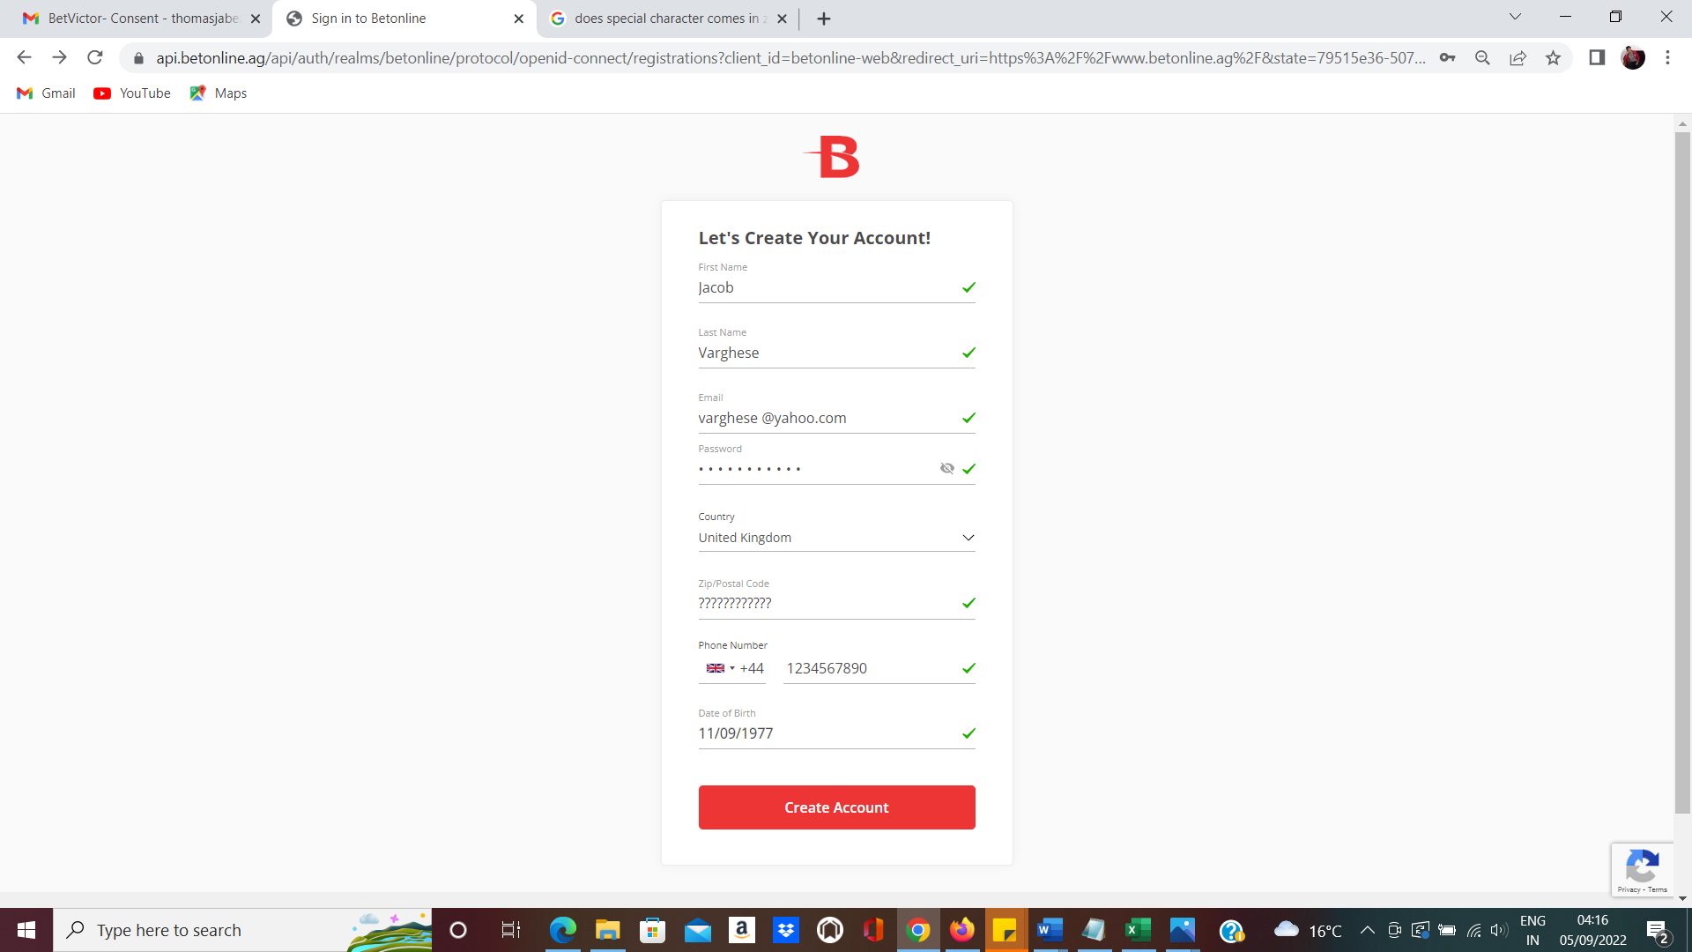

**Defect 2:**

|  |  |
| --- | --- |
| ID number | #12 |
| Name | First name and last name – Space provided between the character not trimmed properly |
| Reporter | Jabez Cherian Thomas |
| Submit Date | 05/09/2022 |
| Summary | When leading ,Middle and trailing spaces entered into first name and Last name fields, spaces entered into these fields should automatically get trimmed on successful account creation. |
| URL | https://www.betonline.ag/ |
| Screenshot | Attached |
| Platform | Windows |
| Operating System | Windows 10 |
| Browser | Chrome 53 |
| Severity | Minor |
| Assigned to | - |
| Priority | Low |

**Description**

When leading ,Middle and trailing spaces entered into first name and Last name fields, spaces entered into these fields should automatically get trimmed on successful account creation.

**Steps to reproduce**

* Go to ‘www.betonline.ag’
* Click on ‘Join’ button.
* Add spaces on leading,middle and trailing in first name and last name field.

**Expected result**

The leading ,Middle and trailing spaces entered into these fields should automatically get trimmed on successful account creation

**Actual result**

Not as Expected-

Space applied in leading , middle and trailing in last name field, not trimmed appropriately.

**Screenshot**

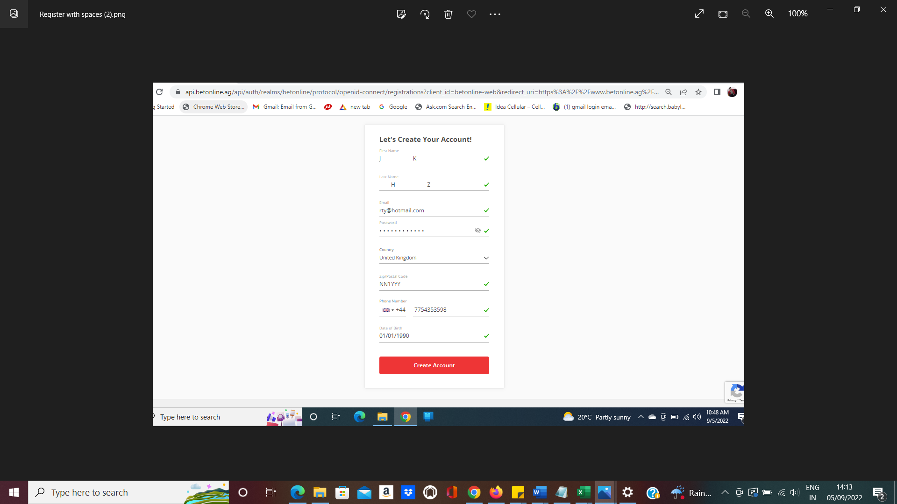

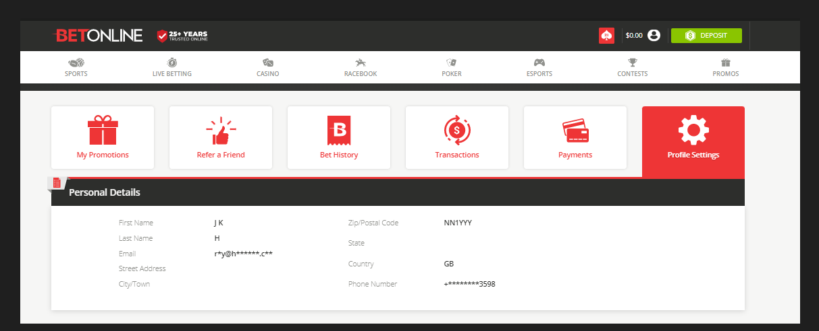

**Defect** #**3:**

|  |  |
| --- | --- |
| ID number | #13 |
| Name | First Name and Last name – Accepting Invalid special characters |
| Reporter | Jabez Cherian Thomas |
| Submit Date | 05/09/2022 |
| Summary | When invalid characters entered on first name and last name fields ,Field level warnings not displayed and invalid characters accepted |
| URL | https://www.betonline.ag/ |
| Screenshot | Attached |
| Platform | Windows |
| Operating System | Windows 10 |
| Browser | Chrome 53 |
| Severity | Minor |
| Assigned to | - |
| Priority | Low |

**Description**

When zip/Postal code field entered with invalid characters on registration page, zip/Postal code accepted as valid.

**Steps to reproduce**

* Go to ‘www.betonline.ag’
* Click on ‘Join’ button.
* Add invalid characters on first name and last name field (see screenshot)

**Expected result**

Proper field level warning should be displayed (i.e,First and last name should not contains any special characters )

**Actual result**

Not as Expected-

Field level warning not displayed ,instead invalid special character accepted.

**Screenshot:**

**Invalid Characters in invalid charecters in first name and last name**

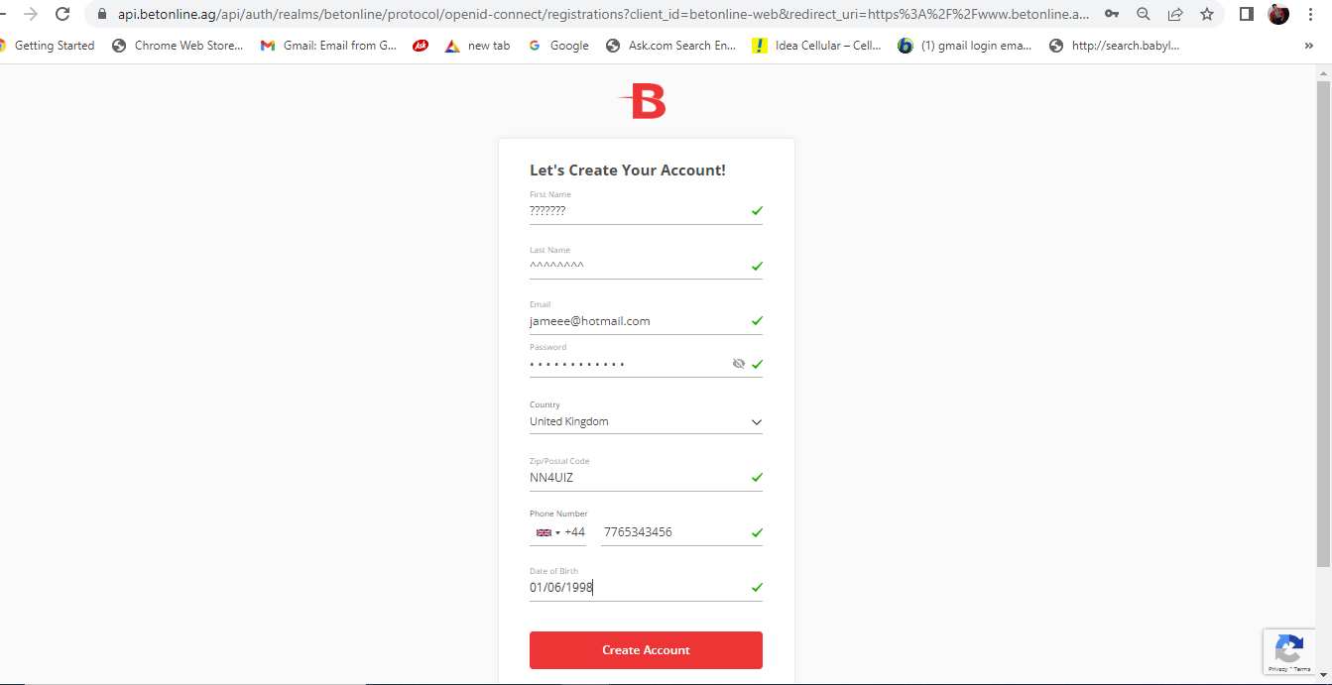

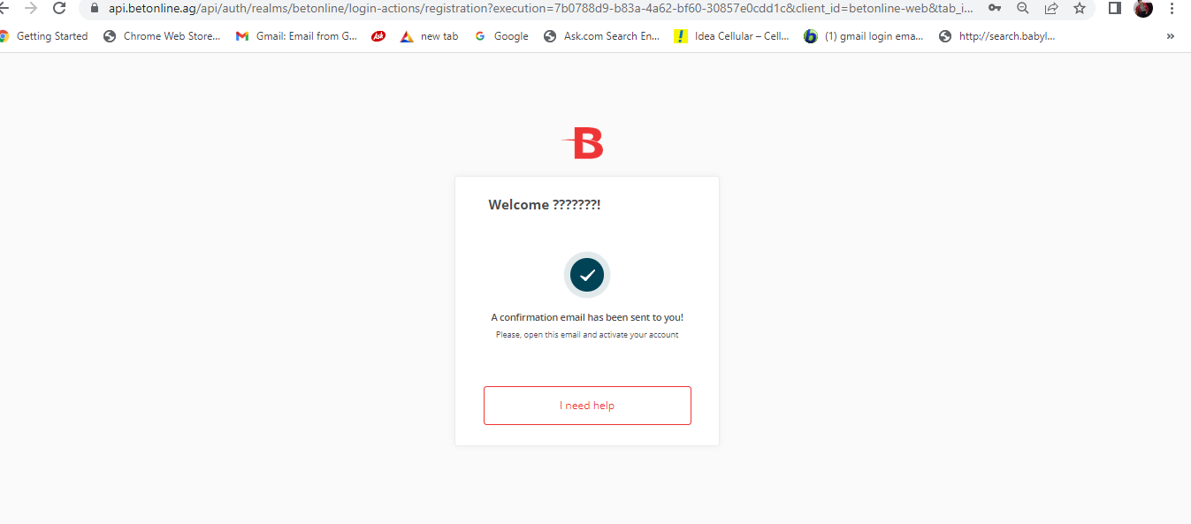

**Defect** #**4:**

|  |  |
| --- | --- |
| ID number | #14 |
| Name | Email Address-Invalid address accepted |
| Reporter | Jabez Cherian Thomas |
| Submit Date | 05/09/2022 |
| Summary | When invalid characters entered on email address fields , Field level warnings not displayed and invalid characters and email address accepted. |
| URL | https://www.betonline.ag/ |
| Screenshot | Attached |
| Platform | Windows |
| Operating System | Windows 10 |
| Browser | Chrome 53 |
| Severity | Minor |
| Assigned to | - |
| Priority | Low |

**Description**

When invalid characters entered on email address fields , Field level warnings not displayed and invalid characters and email address accepted.

**Steps to reproduce**

* Go to ‘www.betonline.ag’
* Click on ‘Join’ button.
* Add invalid characters on email address field (see screenshot)

**Expected result**

Proper field level warning should be displayed (i.e,Please enter valid email address)

**Actual result**

Not as Expected-

Field level warning not displayed ,instead invalid special character and email address accepted.

**Screenshot**

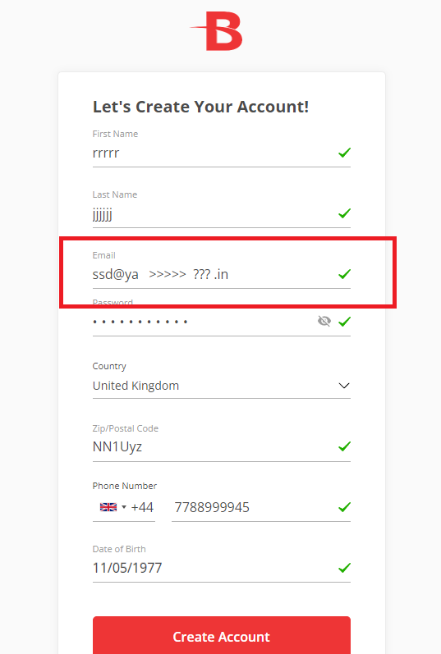

**Defect** #**5:**

|  |  |
| --- | --- |
| ID number | #15 |
| Name | Phone Number-Alphabet is enabled in phone number field |
| Reporter | Jabez Cherian Thomas |
| Submit Date | 05/09/2022 |
| Summary | When alphabets entered in phone number field on registration page, alphabet is enabled |
| URL | https://www.betonline.ag/ |
| Screenshot | Attached |
| Platform | Windows |
| Operating System | Windows 10 |
| Browser | Chrome 53 |
| Severity | Minor |
| Assigned to | - |
| Priority | Low |

**Description**

When alphabets entered in phone number field on registration page, alphabet is enabled.

**Steps to reproduce**

* Go to ‘www.betonline.ag’
* Click on ‘Join’ button.
* Add alphabet in phone number field (see screenshot)

**Expected result**

Alphabet should not be allowed in Phone number field

**Actual result**

Not as Expected

Alphabets enabled in phone number field.

**Screenshots**

